Appendix B: Validation and recruitment timelines

Time of year /  Deadline | Activity / Requirement
September | Tier 1 Panel considers proposals added following final Tier 1 in the previous academic year
October | Tier 1 Panel
November | Tier 1 Panel
December | Deadline for completion of structural changes for the following academic year including option choices, amendments to course structures and delivery pattern updates to be completed; this refers to close of business in December and not calendar month end
January | Tier 1 Panel
February | Tier 1 Panel
March | Deadline for changes to assessments for the following academic year
April | Final Tier 1 Panel
May | Completion of open proposals
June | Completion of open proposals
June | CMA Deadline
July | No validation activity for provision starting September, including chair’s actions (proposals may be submitted for consideration at the following September’s Tier 1)
July | CourseLoop rollover
August | No validation activity for provision starting September, including chair’s actions (proposals may be submitted for consideration at the following September’s Tier 1)

Guide validation timescales

From submission of paperwork to sign-off by the chair of the validation panel is normally a minimum of 9 weeks:

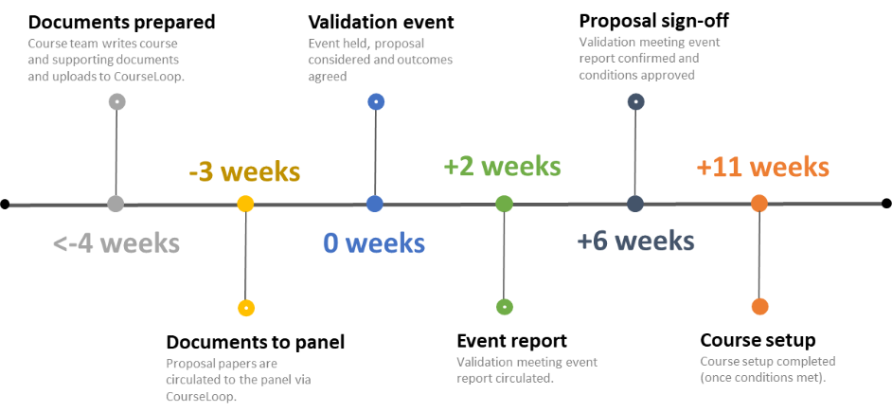

Schools making proposals at a later stage should also be mindful of the potential impact on the recruitment cycle and student numbers on the initial intake:

Recruitment cycle

The UK university recruitment fairs typically run from September to November.

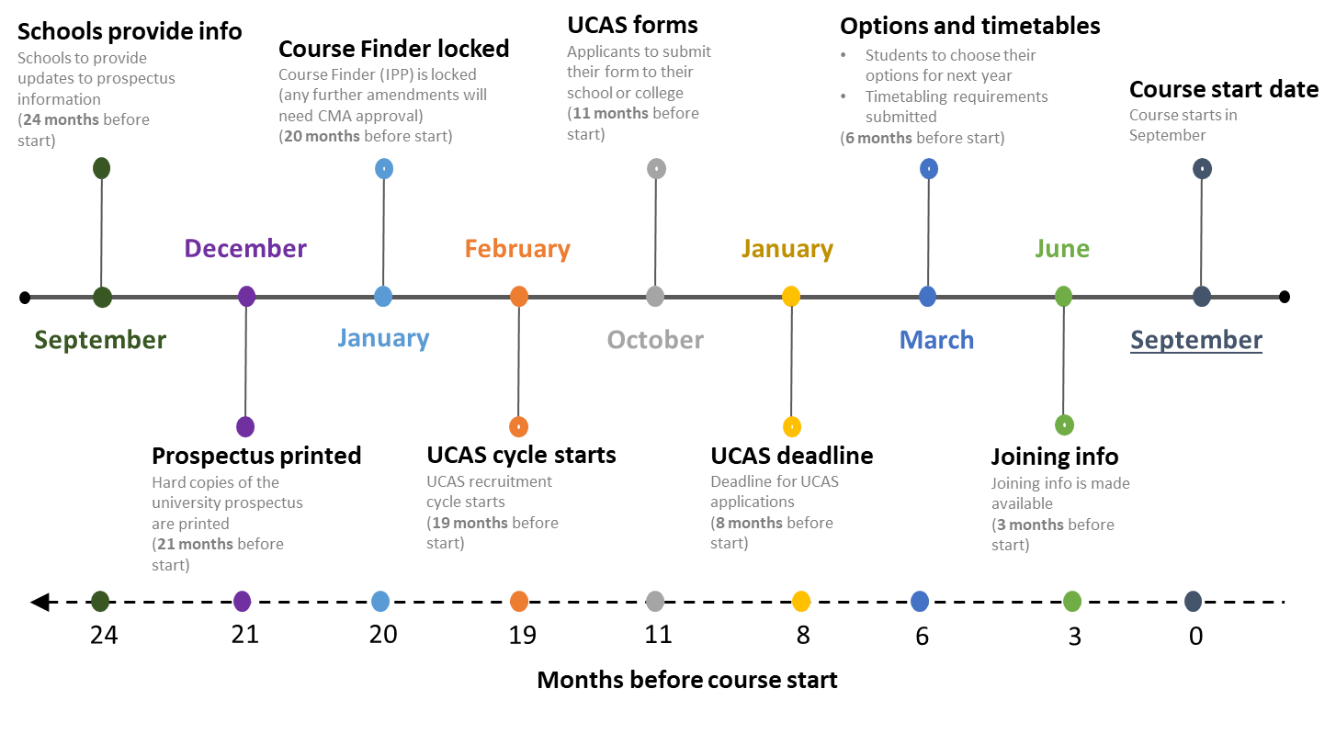

Month | Time before course start date | Marketing and recruitment cycle | Validation cycle
September | 24 months | - Work begins on prospectus and Course Finder. Schools to provide updates to prospectus information  - UCAS applications open for entry the following year | - Validation events
October | 23 months |  | - Validation events
November | 22 months |  | - Validation events  - Deadline for approval of courses for inclusion in the next year’s undergraduate prospectus
December | 21 months | - UG prospectus goes to print for entry in 2 years’ time and no further additions can be made | - Validation events  - RSO requests from schools’ information on new courses and course amendments for the following year’s validation schedule  - Schools begin to confirm courses for inclusion in the Validation Schedule
January | 20 months | - UCAS applications deadline 25 January annually for majority of undergraduate courses commencing in September of that same year  - Course Finder is locked and any further amendments will need CMA approval | - Validation events  - Schools confirm courses for inclusion in the Validation Schedule
February | 19 months | - UCAS recruitment cycle for following year’s entry begins – national recruitment fairs run from February to July  - (UCAS is not open for applications until September)  - Changes will be reflected on Course Finder, subject area pages on the University website (which link the prospectus and Course Finder and are also used for advertising campaigns) and UCAS website | - Validation events
March | 18 months |  | - Validation events  - Schools continue to confirm courses to be added as part of a rolling Validation Schedule
April | 17 months |  | - Validation events
May | 16 months |  | - Schools continue to confirm courses to be added as part of a rolling validation schedule
June | 15 months | - End of UCAS UG application cycle before clearing begins | - Validation events
July | 14 months |  | - Validation events
September | 12 months | - UCAS applications open for entry in the following year  - Work begins on UG prospectus and Course Finder for entry in 2 years’ time | - Validation events
October | 11 months |  | - Validation events
November | 10 months |  | - Validation events  - Deadline for approval of courses for inclusion in the UG prospectus
January | 8 months | - UCAS application deadline | - Validation events  - Schools confirm courses for inclusion in the Validation Schedule
February | 7 months |  | - Validation events
March | 6 months |  | - Validation events  - Schools continue to confirm courses to be added as part of a rolling Validation Schedule
April | 5 months |  | - Validation events
May | 4 months |  | - Schools continue to confirm courses to be added as part of a rolling Validation Schedule
June | 3 months | - Joining information is made available | - Final validation events – no Tier 2 events will take place during July and August  - Schools to submit all CMA Requests by early June
September | 0 months | - Course start dates | - Validation events

