University of Huddersfield Degree Outcomes Statement

December 2024

Purpose of the statement

This statement provides information to prospective applicants, current students, partner

organisations and other stakeholders on how the University manages and assures the quality and standards of our undergraduate awards within the [Regulatory Framework for Higher Education in](https://www.officeforstudents.org.uk/advice-and-guidance/regulation/the-regulatory-framework-for-higher-education-in-england/) [England.](https://www.officeforstudents.org.uk/advice-and-guidance/regulation/the-regulatory-framework-for-higher-education-in-england/) It represents our commitment to protecting the value of our degrees over time and contributes to our academic governance and monitoring processes.

1. Institutional degree classification profile

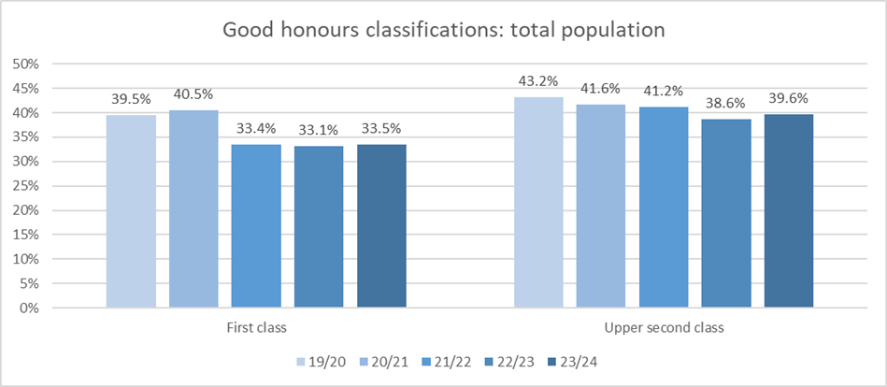

The figures below show the percentage of first class and upper second class degrees awarded by the

University over the past five years. The first table shows how the number of first class degrees rose during 2019/20 and 2020/21 during the global pandemic and had fallen back to pre-pandemic levels by 2021/22. The trend for upper second class degrees remains much flatter over the same period. During 2019/20 and 2020/21 the University applied its emergency regulations, including a Safety Net to reassure students that they would not be disadvantaged due to the unprecedented disruption to their learning.

The 2023/24 academic year saw the number of first class honours remain consistent with both the previous two years and pre-pandemic performance. The number of upper second class degrees awarded rose slightly on the previous year, whilst remaining in line with the longer term pattern.

Figure 1: Profile of institutional degree outcomes over the last 5 years by total population, split by classification

level. The data includes all honours level outcomes, including unclassified. The primary source is the HESA student record, full-time, first degree.

Figure 2: Profile of institutional degree outcomes over the last 5 years, split by demographics. Shows total

numbers of good honours awards. The data includes all honours level outcomes, including unclassified. The primary source is the HESA student record, full-time, first degree.

In line with the general trend across the sector, good degree outcomes have gradually improved

since 2015/16 and had then stabilised at an average of around 75% prior to the pandemic. This was a result of initiatives designed to improve teaching quality, the calibre of our teaching staff, and assessment and feedback practice. We worked with external advisors including Advance HE to help us achieve this improvement.

The University continues to address differential attainment. Initially launched through a HEFCE

catalyst funded project “Intervention for Success”, early initiatives demonstrated impact through a clear uplift attainment in 2019/20 data for those students who identify as Black, Asian or Ethnic Minority heritage (labelled ABMO above). The work has developed into the Huddersfield Differential Attainment Project (HuDAP) which maintains momentum in our goal to eradicate the attainment gaps between different sections of our student population (for more information see section 6 below).

The second table below profiles trends across the student characteristics measured, with a general reduction following the pandemic-related peak. There are, however, differences in the degree of impact across different sections of the population. Mature students (21 and over) saw a significant rise in good honours compared to last year. Those with a non-white ethnicity increased performance whilst white students fell back slightly by comparison. The proportion of good honours increased for those entering with BTECs or other qualifications, whereas the number of those with A-levels fell slightly.

The course assessment strategy is specified when the course is designed and approved. Any subsequent changes to assessment design have to be approved through a formal quality assurance process. All courses undergo a rigorous validation process before being approved for delivery, and as part of that process they are explicitly mapped to the relevant QAA Subject Benchmark Statements, and the requirements of Professional, Statutory and Regulatory Bodies (PSRBs). Course teams develop their courses and assessments in the context of the QAA’s Advice and Guidance: Course Design and Development, and on Assessment.

2. Assessment and marking practices

The University’s policies and practices ensure that we meet the Expectations of the Quality Code for

Higher Education, particularly with respect to protecting the value of our awards and upholding appropriate academic standards over time.

The [Regulations for Awards](https://www.hud.ac.uk/policies/registry/awards-taught/contents/) specify the University’s requirements on the structure of undergraduate

programmes, and our assessment and marking practices. These regulations are reviewed annually and presented to the University Teaching and Learning Committee (UTLC) for scrutiny and approval.

Our Inclusivity Framework for Course Design was approved by UTLC in March 2020. This framework

encapsulates our commitment to ensure all students, including those from protected characteristic groups and diverse backgrounds, can access the learning experience equally and achieve their full potential. It requires those proposing new courses to demonstrate how they will offer an inclusive curriculum and how their assessment strategy will support the University’s strategic aim to eradicate the attainment gap between White students and Black, Asian and Minority Ethnic students.

Staff and students are expected to comply with the University Assessment and Feedback

Framework which has recently been reviewed and developed to build on positive lessons learned during the pandemic. It sets out our vision that assessment will inspire and challenge students and has a strong emphasis on personalised feedback and support.

An important part of the quality assurance process for awards is the external examiner system. The

role of the external examiner is to provide independent and impartial advice on a provider’s academic standards and on students’ achievements in relation to those standards. External examiners are appointed to all programmes and their role is to provide academic peer review. In some subjects, additional examiners are drawn from the relevant profession to ensure that our degree courses continue to prepare students well for their chosen profession. External examiners are expected to undertake University training in order to fulfil their role effectively, and those new to the role are provided with a mentor drawn from the wider external examiner cohort.

3. Classification algorithms

Over the period since 2010, the algorithms used to calculate degree classification have not altered

and the grading scales are set out in the [Regulations for Awards.](https://www.hud.ac.uk/policies/registry/awards-taught/section-6/)

In 2019/20 the algorithms were supplemented by [emergency regulations](https://www.hud.ac.uk/policies/registry/awards-taught/section-8/) (the Safety Net) to ensure

that marks achieved in the 2019/20 academic year did not detrimentally skew a student’s overall

Senior leadership structures for oversight of teaching and learning were strengthened in July 2022

with the formal establishment of the Strategic Teaching and Learning Team, consolidating a wide

The University has a well-established history of intervention through teaching and learning to

improve student attainment. A range of strategic projects are overseen by UTLC and good practice is shared. The Huddersfield Differential Attainment Project (HuDAP) uses attainment data to identify areas for priority intervention to reduce attainment gaps and has led to a number of targeted initiatives. One example of this is *Flying Start*, a transitions initiative to increase confidence in all newly arrived first year students, which has had the impact of improving retention and success across all student groups. To date all Schools have participated in HuDAP workshops, with a focus on developing innovative and robust assessment strategies to scaffold learning and support students to develop ‘real-world’ skills for employment. HuDAP was recognised by Times Higher Education Awards as winner of the Outstanding Contribution to Equality, Diversity and Inclusion category in 2022. HuDAP workshops for 2024-25 will continue to address the differential attainment gap.

During the last five years, the Teaching and Learning Strategy has aligned with the aims of the University Strategy to 2025. As we develop our new strategy to 2030, it will continue to encompass a wide range of initiatives designed to improve teaching quality and a continued emphasis on closing the differential attainment gap.

•

5.

Identifying good practice and actions

All our academic staff undertake research or scholarly activity, and 76% of our permanent

academic staff have PhDs with the remainder working towards one.

All academic staff are Fellows of the HEA (now Advance HE) or working towards this within 12 months of appointment.

We continue to grow our vibrant community of National Teaching Fellows and University Teaching Fellows who act as mentors, trainers and facilitators for innovation in teaching practice. These individuals play an active part in the dissemination of good practice.

To facilitate the operational and organisational aspects of our delivery of teaching and learning, all senior managers are accredited by the Chartered Managers' Institute. Our staff are highly professionalised, and this provides a strong base for delivery of excellence in teaching and learning and consequent positive outcomes across a diverse student population.

profile of performance. For 2020/21, a Grade Safety Policy was developed to enable comparison

between current marks and the historical distribution of marks for that module. Where a statistically significant difference was highlighted, marks could then be scaled to bring them back in line. This applied to all module marks awarded in 2020/21 and 2021/22. The emergency regulations were revoked with effect from 01 August 2022.

4. Teaching practices and learning resources

The following policies and initiatives also contribute to our high teaching standards:

•

•

•

The HuDAP analyses the relative performance of students across a range of recognised

characteristics. Our analysis of module marks provides a granular level of attainment detail which Schools use to plan innovative and inclusive teaching and learning practices appropriate to their context. These interventions are monitored centrally and inform our developing understanding of the efficacy of various initiatives.

Our aim is to reduce the attainment gap to zero and meet one of the KPIs on the current Strategic Plan (2019-2025). This is challenging but is supported through enabling projects including *Flying Start*, Personal Academic Tutor system, Academic Skills support, and a review of assessment design. Progress towards the KPI is monitored by UTLC, the Senior Leadership Team and Council, as well as through an Annual Evaluation process which requires course teams to reflect in detail on what works for their students and where further development is required.

Our commitment to eradicating the attainment gap will be reiterated in the next strategy period to 2030.

The University holds an annual Teaching and Learning conference which encourages innovation and

offers space for sharing good practice across the institution. It supports projects to enhance distance learning, student engagement and staff training and, uses data analytics to inform our understanding of student engagement and differential attainment. Thematic reviews are undertaken periodically; they provide in- depth analysis of a particular aspect of learning and, with the help of external experts and student representatives, facilitate a holistic view of activity across the University to share good practice and highlight areas for development.

range of key teaching and learning interventions developed since 2018. It supports initiatives

across the University, ensuring that professional services and academic staff contribute to institution-wide projects in support of our strategy. It is located within the Registry and Academic Development Service and the synergies between the teams allows more effective delivery of quality assurance and enhancement.

The University continues to develop its virtual learning environment (Brightspace) and provides

comprehensive training and resources for staff around pedagogic practice for in-person, distance delivery and blended learning.

6. Risks and challenges